Appendix

Table A1. Moran’s test results for each species spatial autocorrelation assessment using monthly detection rates.
species | statistic | estimate | p
black bear | 1.09161568 | 0.00113999 | 0.13750103
elk | 4.48388769 | 0.01132731 | 0.00000366
grizzly bear | 0.25475715 | -0.0063893 | 0.39945534
moose | -0.1274164 | -0.0046339 | 0.55069459
mule deer | -2.4129532 | -0.012089 | 0.99208808
red fox | -0.492696 | -0.009002 | 0.68888631
white-tailed deer | -1.9277434 | -0.0058884 | 0.97305647
gray wolf | -0.3369542 | -0.0494261 | 0.6319243
cougar | 0.6879606 | -0.0108369 | 0.2457388

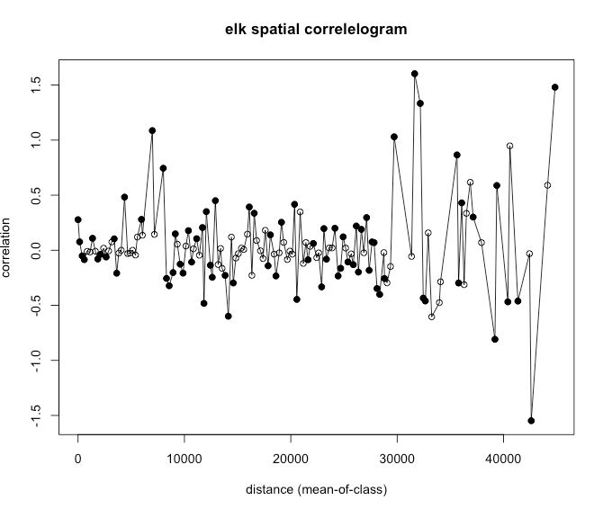
Figure A1. Spatial correlelogram for elk, which had a significant, but biologically small, spatial autocorrelation result from the Moran’s I test.

